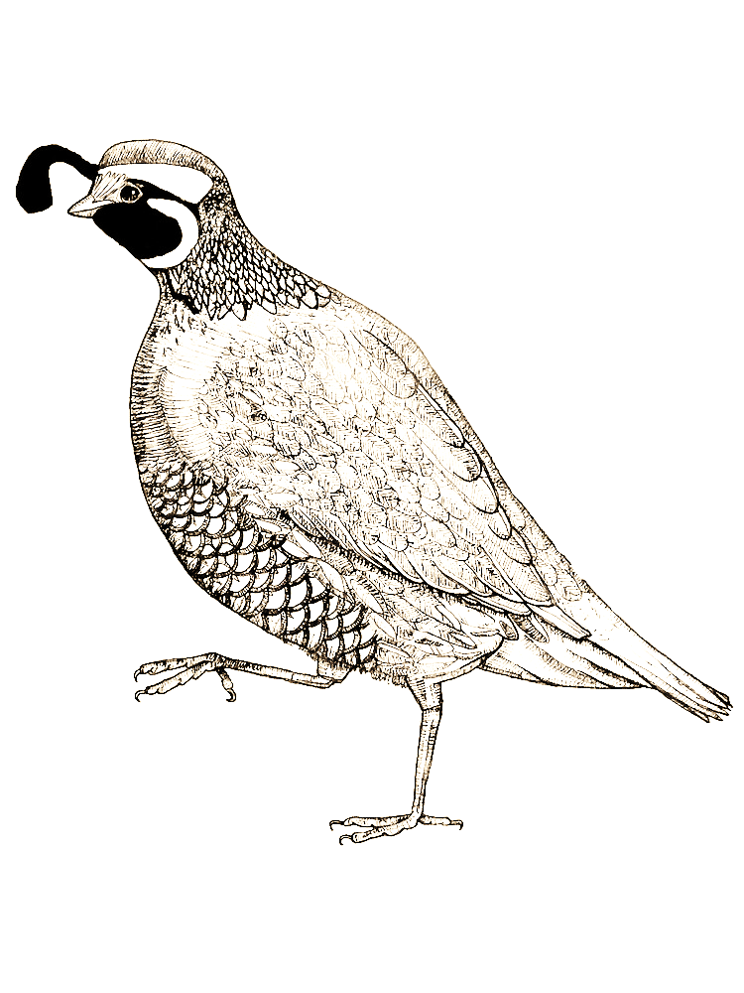
_____________________________________________________________________________________________
Begin Early: Getting in shape is essential for the different types of terrain you can find in Nevada. Break your gear in early!
Get maps and start scouting: Maps and scouting gives you a head start for your hunt. Find areas to hunt and camp before the season opens.
- Know where private property is in your area.
- More than one location is beneficial in your area if your spot becomes occupied or crowded.
- Acquire a guzzler map for locating water developments where you will be hunting.
- Carry plenty of water this time of year to keep yourself hydrated.
Know your Firearm/Practice shooting:
- Find a range and practice and be familiar with your firearm.
- Practice at a sporting clay range to simulate all types of upland game shooting.
Once you get your game in sight you will be more confident of your shot.
- A shotgun must be capable of holding only three rounds for migratory birds. (Dove)
- Removing the plug for all other upland game (Quail, Chukar, Rabbit) is optional in Nevada.
- Non-toxic shot is not required for Dove or upland game in Nevada.
Know the game you are hunting: It sounds funny, but do some research on habits, food sources, and behavior of the species you are hunting, this will be beneficial in the field.
- Some species require leaving a wing attached to the bird, check hunting regulations.
- Game vest work well for carry your harvest, shells, water, snacks and creates visibility.
Safety
- Orange clothing (upland game vest and orange hat) is highly recommended in Nevada, so you are visible to other hunters in your party or others in the field.
- Safety glasses tinted or not is a great idea in the field. This allows better visibility and protection.
- Make sure your firearm is unloaded when placed in the vehicle.

Prepare yourself and your vehicle for weather: Weather changes drastically in Nevada. Search historic weather in the area and prepare yourself and vehicle for anything.

