Deterring Bears with Electrified Fencing:
A beginner’s guide

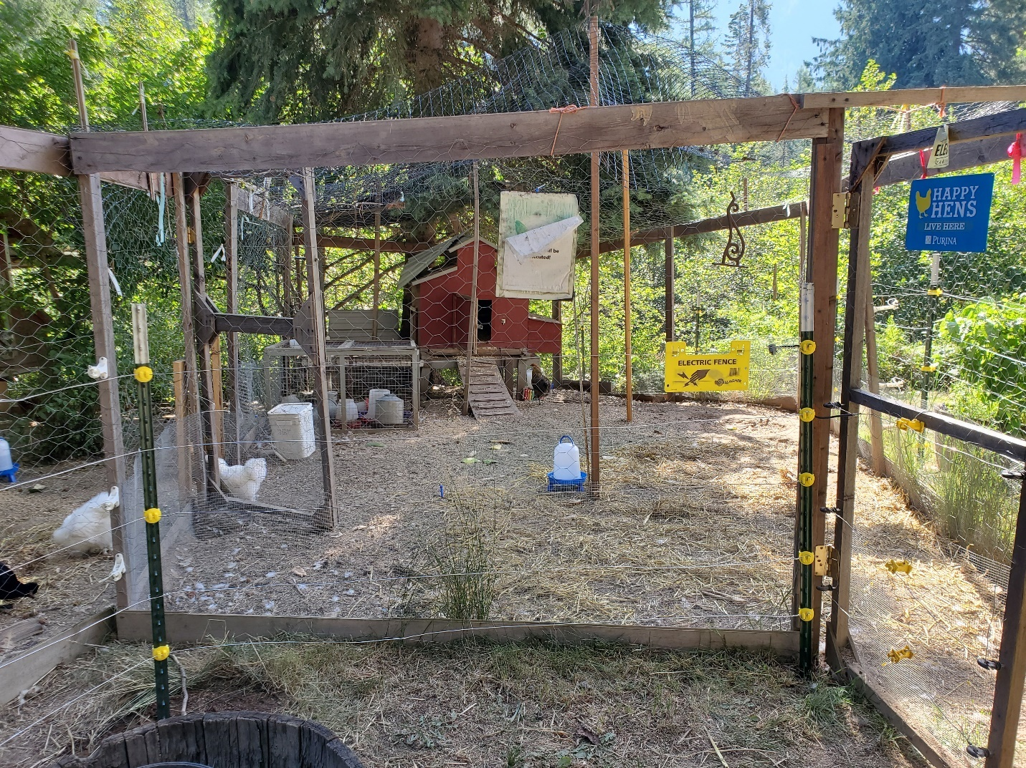

Prepared by
Kim Annis
Human-Carnivore Conflict Specialist
Montana Fish, Wildlife & Parks
March 2022 – version 4.0

This is a “living” document that is updated once every few years. The most recent version of this document can be downloaded from the FWP website: https://fwp.mt.gov/conservation/wildlife-management/bear
Contents
Introduction 1
Getting Started 2
How Electrified Fencing Works 3
Components 3
1. Energizers 4
a) 110-volt AC 5
b) DC-battery 5
c) Solar 5
2. Grounding System 5
a) All-hot fences 6
b) Ground-return fences 6
3. Wire 7
4. Posts 10
5. Insulators 10
5. Voltage meter 10
Electrified Net Fencing 11
Gates 12
Tips and Trouble Shooting 13
Additional Resources 14

Introduction
The purpose of this guide is to provide basic information on properly designing an electrified fence for deterring bears. This guide is designed for people that have had limited or no experience with electrified fencing but are interested in understanding the basics before designing a fence of their own. This guide does not provide information for designing electrified fences to keep in livestock. For detailed information on fencing options, please see the Additional Resources section on the last page of this guide. Proper design, construction, and maintenance will ultimately determine the effectiveness of your electrified fence.

A properly constructed electrified fence is both safe for people, livestock and pets, and has proven effective at deterring bears from human-related resources such as beehives, garbage or small livestock. However, safety is always a concern when using electrified equipment. Modern low impedance energizers have been designed to transfer energy fast enough that a spark generated along the electrical path should not produce enough heat to start a fire. Even though touching an electrified fence is unpleasant, modern energizers are safe and should not produce injury. However, it is always advisable to use common cautions around electrified fencing.

- Do not touch an electrified wire or fence with your head, neck, or spine
- Do not attempt to step over or climb through a fence that is electrified
- Wear appropriate footwear when approaching an electrified fence
- Never electrify barbed wire or use it as a ground-return wire
- Hang warning signs in locations that will warn children, untrained adults or visitors that your fence is electrified
- Make your electrified fence as visible as possible
- Never encourage anyone to touch an electrified fence
- Never touch the positive and negative terminals of an energizer at the same time with anything other than an appropriate electrified fencing voltage meter
- Use an energizer that is appropriate to the distance of wire you are electrifying

What Can Electrified Fences be Used For?
Electrified fencing can be used to secure the human-related foods that attract bears, and to keep them out of areas where they are not wanted. This includes, but is not limited to:

Fruiting trees Garbage containers Songbird feeders
Chicken coops Poultry pens Porches
Chicken feed Small livestock pens Sheds
Livestock feed Beehives Yurts
Dog pens Dumpsters Gardens
Compost Barbeque grills Outdoor fridges and freezers
Harvested game Outbuildings Smokers
Seasonal cabins Orchards Vineyards

Getting Started
There are a few things to consider before designing your electrified fence:

- Will your fence ever need to be moved or taken down? If so, consider a lightweight temporary fencing design. There are many prefabricated electrified netting fences that are quick to install and easy to move. A fence constructed of polywire and plastic or fiberglass posts can be quickly set up and used seasonally or for short periods of time. Alternatively, hog or cattle panels can be used to create small enclosures with several lines of electrified wires attached to the outside. While these fences are easier to construct than permanent fences, temporary fencing designs require more regular maintenance than permanent fencing to keep them running at optimal performance.

- Will you use your electrified fence during months of snow and ice? Some electrified fencing materials handle snow and ice better than others. In winter, solar energizer units may not get enough sun to fully recharge batteries, or the batteries might freeze. Be prepared to do maintenance on fencing that will be partly or entirely buried under snow and ice.

- Are dry weather periods common? Electrified fences rely upon moisture in the soil to conduct electricity that will deliver an effective electric shock. If the soil in your area becomes dry during certain months of the year, if your fence will be on dry, rocky soil, or if your fence crosses pavement, wood or concrete, then you will need to design a ground-return fencing system.

- Will your electrified fence need to secure hoofed livestock as well as exclude bears? Please check with your local agriculture extension agent, or other experts on livestock, for livestock appropriate fencing designs, and on how to train your livestock to respect an electrified fence.

- How large of an area will your electrified fence enclose? For large pasture, orchard or property boundary fences, consider the size of the energizer needed to power your electric fence. Large acreage fences will need higher Joule rated energizers to provide optimal power to the entire fence.

How Electrified Fencing Works
When an animal touches an electrified wire and the ground simultaneously, the electric current passes from the wire through the animal, into the ground, to the ground rod, and back to the energizer (Figure 1). The electrical current is then completed and the animal receives a shock. However, if the soil is too dry, or the grounding is inadequate, the electric current will be unable to find a path back to the energizer, resulting in the animal receiving little or no shock.

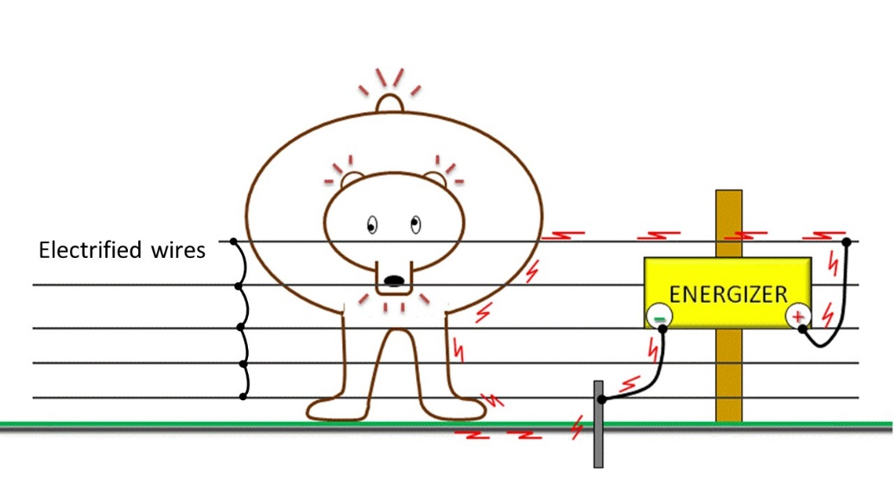
Figure 1. A bear touches an electrified wire, completing the electrical circuit, and receives a shock

For an electrified fence to be effective against bears, the design should be constructed so that bears cannot climb through, over or under the fence without receiving a shock. This requires constructing a fence that:

- Has multiple electrified wires (see Figure 2)
- Is a combination of electrified and ground-return wires (see Figure 3)
- Is a combination of electrified wires on the outside of an existing fence (see Figure 7), or
- Is prefabricated electrified netting (see Figure 10)

Components
The 6 primary components of an electrified fence are:
- Energizer
- Grounding system
- All-hot fences
- Ground-return fences
- Wires
- Posts
- Insulators
- Voltage meter

Additional materials may be necessary depending on the design of your particular fence. Other materials may simply add convenience, such as on/off throw switches, and can be added as desired.

1. Energizers
Energizers are the power source for your electrified fence. Energizers come in a wide variety of makes and models, but all of them are designed to store energy and deliver it in short pulses through the connected wires. To effectively deter bears, your energizer needs to pulse at a rate of 45-60 pulses per minute, which is approximately 1.0-1.5 pulses per second.

Energizer manufacturing companies rate their products with an energy measurement unit called a JOULE. A Joule is a measure of stored or released energy. The Joule rating of energizers typically have 1 of 2 classifications; Stored or Output. The Stored classification is the maximum number of Joules that the energizer can store when not delivering energy to a fence. The Output classification is the maximum number of Joules that the energizer can deliver to a fence. The number of Joules Stored will always be higher than Output. For example, an energizer listed as having 1.0 Stored Joules will be able to deliver approximately 0.7 Joules to the fence.

The amount of Stored or Output Joules does not directly translate to the amount of voltage an energizer can deliver, nor to how powerful the electric shock will be. The higher the Joule rating of an energizer means it has a higher amperage. It is amperage, not voltage, that determines how powerful a shock will feel. For example, while both a 0.2 Joule and 1.0 Joule rated energizer can deliver a 7,000-volt shock, the 1.0 Joule energizer has higher amperage. Therefore, a 7,000-volt shock delivered by a 1.0 Joule energizer will feel more powerful than a 7,000-volt shock from a 0.2 Joule energizer. In plain terms, a 1.0 Joule energizer has a more painful shock value than a 0.2 Joule energizer.

Bears are more likely to pay attention to an electrified fence that delivers a painful shock. Therefore, for deterring bears in developed areas, your energizer will require a minimum Joule rating of:

0.7-1.0 Stored Joules or 0.5-0.7 Output Joules

Low cost, slow pulse rate, low Joule rated energizers are abundantly available and may be adequate for livestock or pet-yard applications. However, these energizers will not be effective at deterring bears. Similarly, older energizers that were not designed with modern safety features may be unsafe to use. And high Joule rated energizers are too powerful for small applications; bigger is not necessarily better.

High impedance energizers are not recommended; these energizers may also be labeled as continuous current, weed burner or weed chopper. High impedance energizers have a pulse that is long in duration, but low in energy. These long duration, continuous current pulses can create a spark that can produce enough heat to set fire to vegetation. Only low impedance energizers are recommended for deterring bears. Low impedance energizers have pulses that are short in duration, but higher in energy. Low impedance pulses are so short, less than 3/10,000 of a second, that a spark should not produce enough heat to start a fire. This short duration pulse also allows people and animals time to move away from a shock safely.

There are 3 basic models of energizer to choose from:
a) 110-volt AC: These plug-in style energizers connect directly to a 110-volt outlet (standard household current). AC energizers are the least costly type of energizer to purchase and operate. Their standard pulse rate is 50-60 pulses per minute, receive consistent power and require less maintenance than DC-battery or solar units. Whenever possible, AC energizers are recommended for electrified fencing. Some styles of AC energizers have on/off switches while others have to be directly unplugged to be turned off.

b) DC-battery: These energizers receive their power from 6-volt or 12-volt DC (deep cycle) or marine batteries. These energizers are just as effective as their AC counterparts and are more versatile for location placement along your fence. However, because DC energizers do not come with batteries, the batteries that power the energizers are an added expense, making the overall cost of using DC energizers higher than AC energizers. To extend battery life, some DC energizers have a very slow per-minute pulse rates, so be certain to purchase one that pulses at the recommended 45-60 pulses per minute. The batteries that power DC energizers must be regularly recharged for your fence to remain at optimal performance, therefore DC energizers will require more regular maintenance than AC energizers.

c) Solar: Solar energizers consist of a solar panel directly attached to both a rechargeable battery and a DC energizer, often sold as a single unit with battery and energizer enclosed in a case or housing. Solar panels can be purchased separately and added to a DC energizer, but the array must be powerful enough to keep a deep-cycle battery charged. Your solar energizer must be placed in a location where it will receive enough sunlight to provide a sustainable charge for the battery. While these energizers are the most versatile, they consist of 3 separate parts (solar panel, battery, and energizer) and therefore are the most expensive and highest maintenance option for powering an electrified fence.

2. Grounding System
Adequate grounding is an important component in the function of all electrified fencing. Without adequate grounding, an electrified fence will be unable to deliver an appropriate shock to an animal; electricity must be able to easily flow from the soil to the grounding rod, back to the energizer, for an animal to receive an adequate shock (see Figure 1). For adequate grounding, all electrified fences will need a minimum of 3 to 6 feet of grounding rod per 1 Joule of stored energy from your energizer. However, you cannot create too much grounding in your fencing design. Think of ground rods as an "antenna" that collects the energy needed to create a shock; the bigger the antenna, the bigger the shock.

Grounding rods should be at least ½” in diameter and made of galvanized steel. Non-galvanized steel, rebar, steel posts, or painted metals are not recommended; paint and rust are poor conductors of electricity. Copper grounding rods are also not recommended for electrified fencing as they can cause electrolysis and eventually corrode connections. Never attach your electrified fence to a grounding rod used for a buildings electrical system. Make sure that your ground rods are as far as possible from utility connections and water pipes. If electrical fencing grounding rods are too close to the utility grounding rods they can cause inference in your utilities, or electrical induction into your water pipes.

To form a proper connection, grounding rod clamps should be used to attach the energizer to the grounding rod. Grounding rods should be driven deeply into the ground near the energizer. The standard length of galvanized steel grounding rods are 6-8 feet and, if possible, a ground rod should be driven into the ground nearly its entire length. Dry or rocky soils do not conduct electricity well, reducing the amount of energy that will reach back to a single grounding rod and reducing the effectiveness of your electrified fence. In dry or rocky soils, several grounding rods should be used, driven as deep as possible, spaced 10-feet apart and connected in a series. If soils are very dry during several months each year, consider designing a ground-return electrified fence in addition to several deeply placed grounding rods.

a) All-hot fences
In an all-hot electrified fence design, all of the wires are electrified (i.e. hot or +). One wire is directly connected to the positive terminal on the energizer, and then all remaining wires are connected in a series to each other. The negative terminal on the energizer (i.e. ground or -) is directly connected to only the grounding rod. When an animal is standing directly on soil and touches just one of the electrified wires, it will receive a shock. The electrical current will travel from the energizer, through the wire, into the animal, into the soil, to the grounding rod and back to the energizer. The electrical current is completed resulting in the animal receiving a shock (Figure 2).

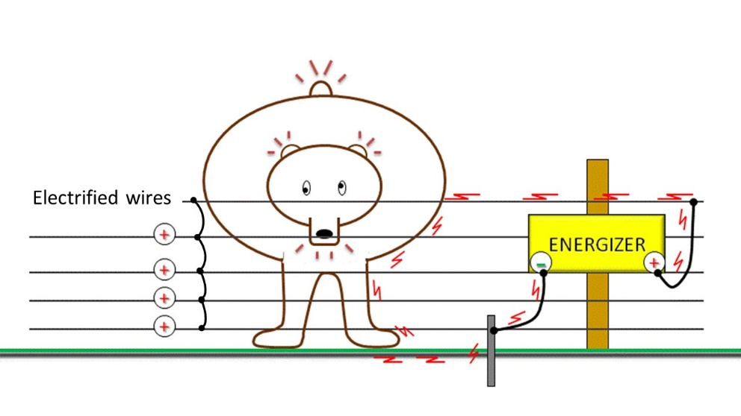
Figure 2. An all-hot electrified fence design. All wires are connected to each other in series and to the positive terminal on the energizer. The negative terminal of the energizer is connected to the grounding rod.

For excluding bears, at least 5 electrified wires are recommended. Place the lowest wire approximately 8-12” above the ground and the top wire at least 36-42” high. Bears are not good jumpers, so electrified lines should be spaced to prevent a bear from going under, passing through or climbing over without fully touching at least 1 of the wires. All-hot fencing designs are only appropriate for locations where the soil is moist year-round, either naturally or because of frequent watering.

b) Ground-return fences
A ground-return electrical fence design consists of alternating hot (+) and ground (-) wires. One hot wire is directly connected to the energizers positive terminal, and all remaining hot wires are connected to each other in a series. One ground wire is directly connected to the energizers negative terminal, and all remaining ground wires are connected to each other in a series. The grounding rod is also directly connected to the energizers negative terminal (Figure 3). This design directly returns electrical current back to the energizer through all ground wires, instead of solely relying on conducting electricity back through the soil and grounding rod. The animal touches both a hot and a ground wire simultaneously to receive a full shock. This design should be used in locations where soils are dry for much of the year, where soils are very rocky or where conditions to deeply place grounding rods is poor.

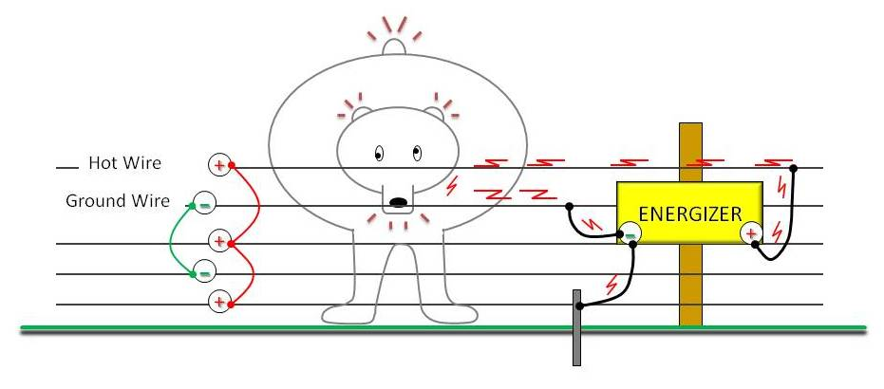
Figure 3. A ground-return electrified fence design. All hot wires are connected to each other in series and to the positive terminal on the energizer. All ground wires are connected to each other and to the negative terminal on the energizer. The negative terminal of the energizer is also connected to a grounding rod.

A minimum of 5 wires are recommended, with the top and bottom lines hot. Place the lowest wire approximately 8-12” above the ground and the top wire at least 36-42” high. Lines should be spaced to prevent a bear from going under, passing through, or climbing over without fully touching 2 of the wires.

Based on the principals of these 2 different wiring systems, there are many fence designs that can be created. For example, if you already have a fence constructed of field wire and t-posts, you can add several electrical lines on the outside of the field fence to prevent a bear from climbing over, under or pushing through the fence. The field fence would be connected directly to the energizers negative terminal and act as the fences ground (-) lines. This creates another type of ground-return fence. When a bear touches one of the hot lines and the grounded field wire together, they will receive a full electric shock that doesn’t require the energy to travel through the soil to complete the circuit.

3. Wire
Galvanized smooth steel or aluminum wire should always be used in the construction of a permanent electrified fence. Galvanized smooth steel wire is strong and durable, but is rigid and larger gauges can be difficult to tighten in small fence designs. Aluminum wire is lightweight and easy to use, but will break with repeated bending. No matter which style you choose, a permanent electrified fence is most effective when designed with 12-14-gauge wire. For some very small fence designs, covering very short distances, 16-gauge wire can be used. Alternatively, very large fences covering long distances should be designed with 10-12-gauge wire.

For temporary, seasonal, or portable electrified fencing, consider the use of polyethylene wire, also called polywire (Figure 4). Polywire consists of many strands of wire braided within a polyethylene rope. Polywire is flexible, strong and can be unrolled and re-rolled multiple times without breaking. It is recommended that your polywire have at least 9-strands of aluminum wire imbedded within the polyethylene. Polywire will degrade and break after long exposures to sun. Polytape, which is flat instead of rope-like, is less effective for deterring bears and not recommended.

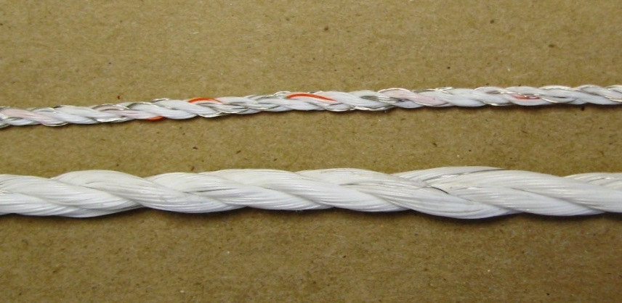
Figure 4. Two different styles of 9-stranded Polywire

To connect energizers to fences, multiple strands of fencing wire in a series, and to connect multiple sections of fencing together, use 10-14-gauge insulated wire specifically designed for electrified fences (Figure 5). This type of wire may be called insulated underground wire and is rated for 20,000 volts. Do not use household or industrial wire, as it is rated for less than 1,000 volts and is not appropriate for an electrified fencing system.

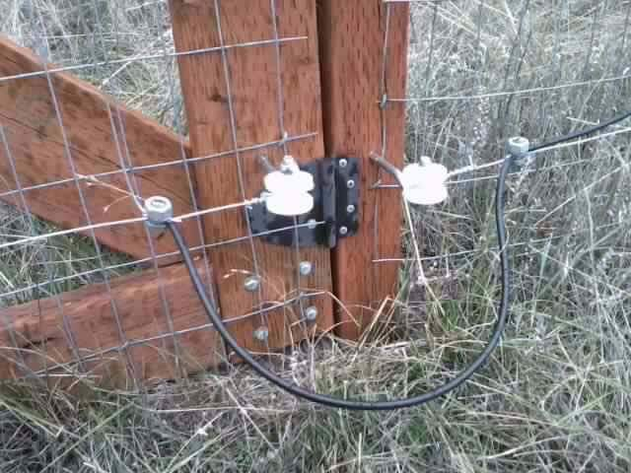
Figure 5. Black-colored insulated electric fence wire, 12-gauge. Used here to connect the electrified lines of a gate to the main electrified lines on the fence.

Additional Design ideas
Depending on the size of your fence and the application, field fencing or wire panels can be used in addition to, or instead of, strands electrified wire. For example, wire panels or field fencing can be raised completely off the ground by attaching them to fiberglass posts, and then fully electrified. The wire panel or field fence would be directly attached to the positive terminal of the energizer (Figure 6). Because they are raised above the soil and attached to fiberglass posts, the panels would be insulated and remain fully electrified, similar to an all-hot wire fence design.

Figure 6. Electrified rigid wire panel. The panel is raised off the ground and insulated by hanging it from fiberglass posts or plastic insulators. The wire panel is electrified by connecting it directly to the positive terminal on the energizer. The ground rod is connected to the negative terminal of the energizer.

Alternatively, wire panels or existing field fence could be used as grounded wires in a ground-return wire fence design. A minimum of 3 electrified wires would be added to the outside of the panels or field fence to prevent a bear from climbing over, under or pushing through the existing fence. The wire panel or field fence is connected directly to the energizers negative terminal. When the animal touches one of the hot lines and the grounded field wire together, it will receive a full electric shock that doesn’t require the energy to travel through the soil to complete the circuit (Figure 7).

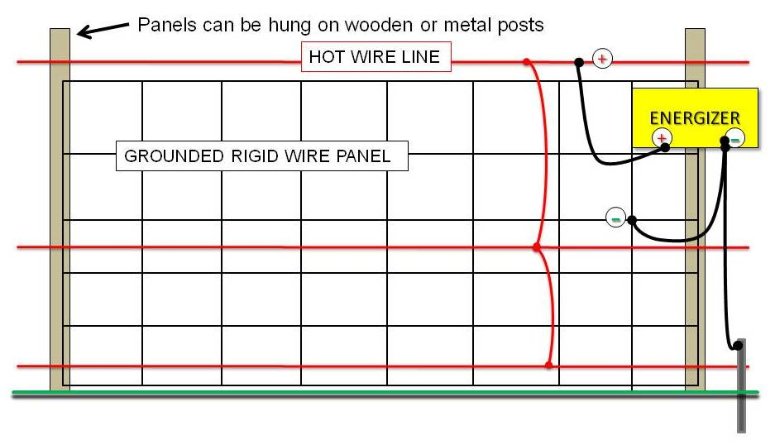
Figure 7. Rigid wire panel or field fencing with 3-electrified wires attached to the outside of the fence. The electrified wires are connected in a series and attached to the positive terminal of the energizer. Then panel or field fence is connected to the negative terminal of the energizer. The ground rod is also connected to the negative terminal of the energizer.

4. Posts
The primary difference between a permanent and temporary electrified fence is your choice of fencing posts and the extent to which they are installed. For low maintenance, permanent fences, treated wooden posts, particularly the corner posts, are the best choice. Less permanent fences can be constructed using metal T-posts or fiberglass posts. And seasonal use or portable fences are typically constructed using step-in-the-ground plastic posts or fiberglass posts. Wooden posts and metal T-posts should be braced at corners and gates. Flexible plastic and fiberglass posts will need support lines placed on the outside of corners and wherever the fence has an abrupt ending.

5. Insulators
To prevent electrified wires from leaking electricity into the soil through conductive materials, wooden posts and metal T-posts will need insulators to hold electrified wires away from the posts. Insulators are commonly made of plastic or ceramic, and are clipped on to T-posts or nailed into wooden posts. There are hundreds of types of insulators available, all designed for different uses and designs. Look for insulators that are the most suitable for the posts and design of your particular fence.
For electrified wires added to the outside of field fences or wire panels, look for insulators that will hold electrified wires 4-6” away from posts and metal fencing. For wooden corner posts and end posts, heavy-duty lag-corner bolts are recommended (Figure 8) and should be placed so that the wire can complete the turn around the outside of the post without any part of the electrified wire touching the post.

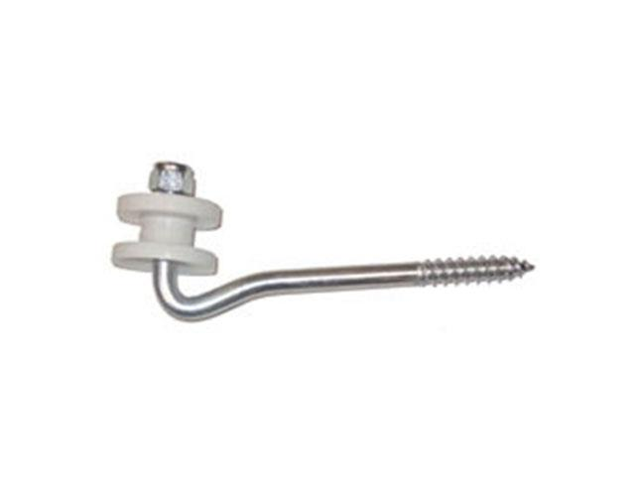
Figure 8. One style of heavy-duty lag-bolt insulator for corner and end posts.

Plastic and fiberglass are non-conductive materials and these posts typically come with built-in clips or notches to hold up each line of electrified wire. Holes can be even drilled through them and electrified wire can be fed directly through each post hole. Plastic and fiberglass posts usually do not need insulators added to them.

5. Voltage meter
Regular and proper maintenance will ultimately determine the effectiveness of your electrified fence. Your most important maintenance tool is an electric fence voltage meter (Figure 9), sometimes called a fence tester. These are meters that are specifically designed to determine the voltage of an electrified fence. Voltage meters designed for use on vehicle or household current are not appropriate and will not work on electrified fences. These small devices tell you not only if your energizer and grounding system are functioning properly, they also tell you the amount of current passing through your electrified wires. This is not the same as a voltage reader. Voltage readers only tell you if electrical current is passing through a wire. A voltage meter tells you how much electrical current is passing through a wire, and it is the how much that matters. Bears require a minimum of 5,000-7,000 volts of electricity to be deterred (depending on the species and the bears level of experience).

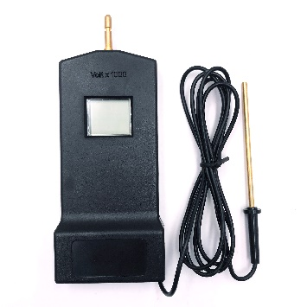
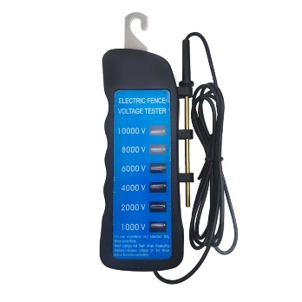
Voltage meters come in inexpensive models that have multiple LED lights that light up when a certain amount of voltage passes through it (Figure 9, left), to slightly more expensive models that give you an exact digital readout of the amount of voltage passing thought it (Figure 9, right). Electric fence voltage meters should be used to test a fences functionality immediately after setup and then periodically thereafter as a part of regular fence maintenance.

Figure 9. Two common styles of electric fencing voltage meters, LED (left) and digital (right).

Electrified Net Fencing
Prefabricated electrified netting creates quick and easy temporary fences that can be used to keep out wildlife. These fences were designed to create small moveable grazing pastures for small livestock, such as chickens, sheep and goats, while keeping them safe from ground predators. They can be used to prevent bears from accessing fruit trees, chicken coops, garbage, or anywhere else bears need to be excluded from. Electrified netting is a combination of horizontal and vertical polywires permanently attached to step-in-the-ground posts (Figure 10). They are commonly premanufactured in 25 to 164-foot lengths and can be connected in series to create longer or shorter fences.

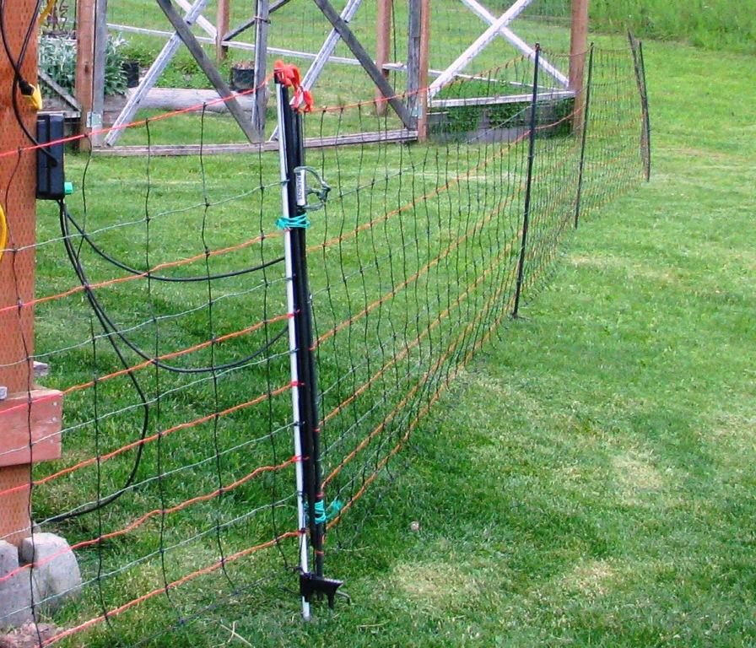
Figure 10. A premanufactured ground-return (pos/neg) electric net fence. The orange horizontal wires are electrified and the green horizontal wires are grounded.
These fences are fully portable and require no special tools to install. The only additional materials needed is an energizer and grounding rod. Electrified netting does not need to connect back onto itself (i.e. create a circle) in order to function. Some drawbacks of these fences are that they are meant for temporary use and will need regular adjusting to prevent sagging over time. The fence line will need to be moved for regular weed cutting or mowing, they can be difficult to place in hard ground, and the fences do not handle snow or ice loads well. This type of fence does not deter deer and often they will pull up the fence, possibly damaging it, when attempting to jump over. Electrified netting come in all-hot or ground-return (commonly called pos/neg) designs. For excluding bears, the ground-return (pos/neg) design is recommended.

Gates
A common question people have is how to design a fence with gates. If a gate is the only non-electrified portion of a fence, a bear is likely to discover it and use that spot to gain access to whatever is behind the fence. Therefore, whenever possible, gates should always be electrified. Think of gates as miniature sections of fencing. Electrified wires are placed on the outside of the gate the same way they would be placed on a main section of fencing, taking care to not have electrified wires too close to gate handles. The wires on a gate are electrified by attaching one of the wires to the main fence with insulated electric fencing wire, as previously seen in Figure 5. Additional wires on the gate are electrified by attaching them in series to the wire connected to the main fence. To connect 2 sections of fencing together with a gate in between, insulated electric fencing wire can be run in the ground under the gate, or over the gate if an archway exists (Figure 10).

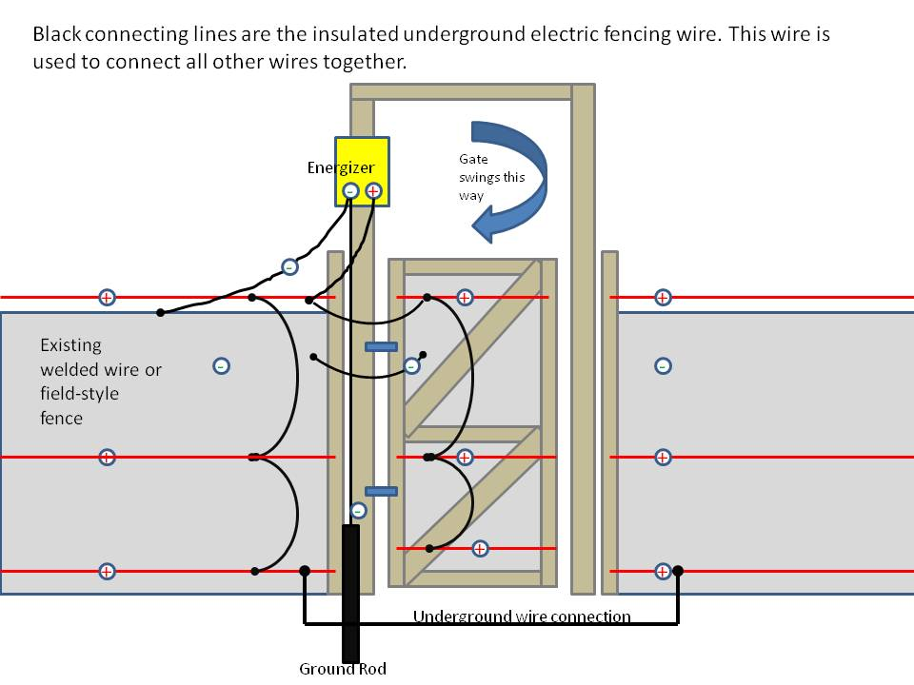
Figure 11. An example of how a gate can be electrified by attaching it to the electrified lines on the main fence, and how 2 sections of fence can be electrified with an underground wire connection.

Tips and Trouble Shooting

- Grounding is the most important component in the design of your electrified fence. Inadequately grounded fences will deliver weak shocks and be ineffective for deterring bears.

- If using a solar or DC operated energizer, check the charge on your battery often. Check battery terminals for corrosion and adequate connection.

- Check that electrified wires are not touching heavy vegetation, fallen branches, posts, or other wires.

- Check for poor connections in spots where electrified wires have been spliced together. When possible, use crimp sleeves, brass ferrules, or other splicers to make connections.

- Check voltage on electrified wires weekly and as part of your fence maintenance routine.

- Place electric fencing signs along the perimeter of your fence and at gates to improve visibility and warn people the fence is electrified.

- Whenever possible, place fencing 3-5 feet away from the structures they are protecting, such as chicken coops or rabbit hutches. This way the bear encounters the electrified fence before reaching the structure itself.

- When protecting fruiting trees, place your electrified fence so that all fruit falls inside the fence boundary instead of outside it.

- Visit the Premier 1 Supply Company’s website to learn some Common Fencing Mistakes.

- Visit the Defenders of Wildlife You Tube page to watch a video on how to add electrified fence lines to the outside of an existing fence.

Additional Resources
Once you have a basic understanding of how an electrified fence functions, you can create many designs with these basic concepts in mind. You can create an electrified mat that lies flat on the ground to prevent bears from accessing a doorway, gateway or driveway. You could electrify a metal bird feeder, a door, or even harvested game, all with using these same basic electrified fencing concepts. For more information on how to create these and other unique electrified fences, please visit:

Living With Wildlife Foundation at www.lwwf.org
- Guides on electric fencing, bear-resistant containers and living with predators

Defenders of Wildlife at www.defenders.org/got-grizzlies
- How to Install an Electric Fence video, information on their electric fencing incentive program

Gillian Sanders from BC, Canada https://www.youtube.com/watch?v=lqIRMavnahE
- How to Electric Fence Against Bears video

Nevada Department of Wildlife
http://www.ndow.org

For Information Specific to bears:
https://www.ndow.org/blog/living-with-bears/#

For Wildlife issues, please call the Nevada Department of Wildlife’s dispatch center: 775-688-1331

For Bear Related Issues, please call the NDOW bear hotline: 775-688-BEAR

WWW.BEARWISE.ORG

