FY23 Nevada CWD Summary
CWD SURVEILLANCE CONDUCTED BY THE NEVADA DEPARTMENT OF WILDLIFE.
Reporting period: July 1, 2022, to June 30, 2023.
Introduction: In fiscal year 2023, the Nevada Department of Wildlife Sampled 416 animals from over 64 hunt units for Chronic Wasting Disease, the majority of which were adult mule deer. All animals were negative. Based on the last several years of sampling, we believe Nevada remains CWD free. The data below outlines the findings from FY23.

Numbers Sampled:
Hunt Unit | Elk Total | Mule Deer Total | Total | Mortality /HBC
11 | 0 | 1 | 1 | 0
21 | 0 | 1 | 1 | 0
31 | 0 | 2 | 2 | 1
33 | 0 | 1 | 1 | 0
51 | 0 | 5 | 5 | 0
61 | 1 | 3 | 4 | 0
62 | 0 | 4 | 4 | 0
65 | 0 | 2 | 2 | 1
66 | 0 | 1 | 1 | 0
67 | 0 | 4 | 4 | 0
68 | 0 | 7 | 7 | 0
71 | 2 | 3 | 5 | 0
72 | 3 | 7 | 10 | 0
73 | 0 | 3 | 3 | 0
74 | 0 | 2 | 2 | 0
77 | 5 | 4 | 9 | 0
79 | 1 | 0 | 1 | 0
81 | 5 | 1 | 6 | 0
101 | 1 | 11 | 12 | 1
102 | 3 | 35 | 38 | 3
103 | 0 | 7 | 7 | 1
104 | 1 | 6 | 7 | 0
106 | 1 | 0 | 1 | 0
107 | 1 | 0 | 1 | 1
108 | 0 | 3 | 3 | 0
109 | 0 | 1 | 1 | 0
111 | 8 | 32 | 40 | 0
113 | 2 | 1 | 3 | 0
114 | 1 | 7 | 8 | 0
115 | 4 | 2 | 6 | 1
121 | 8 | 8 | 16 | 0
131 | 1 | 4 | 5 | 0
132 | 0 | 1 | 1 | 0
141 | 0 | 3 | 3 | 0

Hunt Unit | Elk Total | Mule Deer Total | Total | Mortality /HBC
142 | 0 | 2 | 2 | 0
143 | 0 | 3 | 3 | 0
144 | 0 | 29 | 29 | 0
145 | 0 | 2 | 2 | 0
151 | 0 | 1 | 1 | 1
152 | 0 | 2 | 2 | 1
153 | 0 | 2 | 2 | 0
154 | 0 | 15 | 15 | 0
155 | 0 | 7 | 7 | 0
156 | 0 | 1 | 1 | 0
161 | 0 | 2 | 2 | 0
162 | 2 | 1 | 3 | 0
163 | 1 | 1 | 2 | 0
164 | 0 | 2 | 2 | 0
171 | 0 | 2 | 2 | 0
173 | 0 | 21 | 21 | 1
181 | 0 | 2 | 2 | 0
184 | 0 | 1 | 1 | 0
194 | 0 | 2 | 2 | 2
221 | 5 | 4 | 9 | 0
222 | 5 | 7 | 12 | 0
223 | 0 | 2 | 2 | 0
231 | 8 | 11 | 19 | 0
241 | 0 | 1 | 1 | 0
242 | 0 | 3 | 3 | 0
251 | 0 | 1 | 1 | 0
262 | 0 | 5 | 5 | 0
291 | 0 | 4 | 4 | 0
Unknown | 1 | 3 | 4 | 0
Total | 74 | 340 | 414 | 14

Sampling by Sex and Age Class
 | Fawn |  | Yearling |  | Adult |  | All | Hunt Units Sampled
 | Male | Female | Male | Female | Male | Female
Mule Deer | 1 | 2 | 47 | 3 | 255 | 34 | 342 | 61
Elk | 0 | 0 | 2 | 0 | 56 | 15 | 73 | 24

By Region:

Sampling Regions: 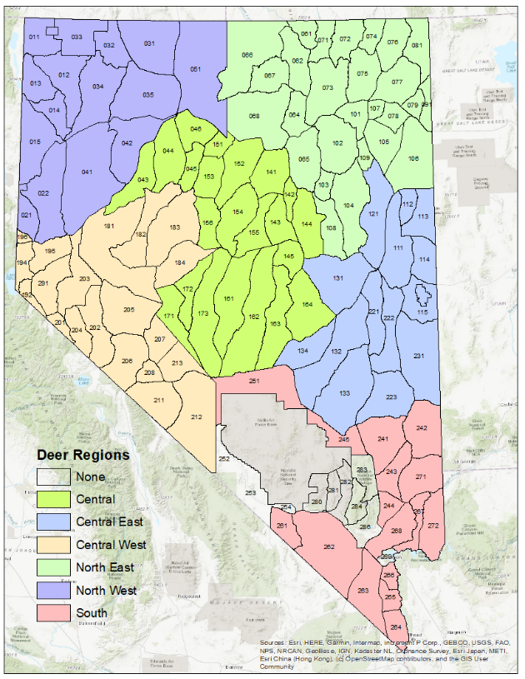
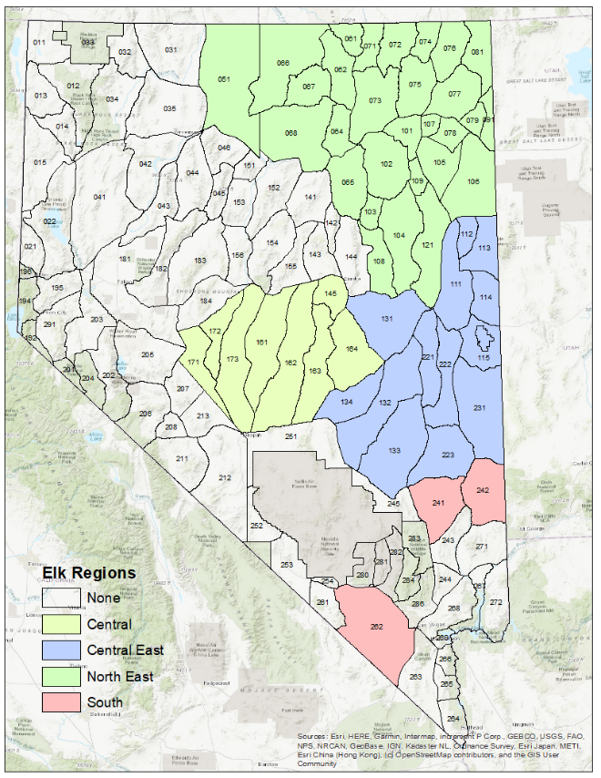

Sampling by Regions:
Region | Mule Deer | Elk | Total | % Negative
North East | 135 | 36 | 171 | 100%
North West | 10 | 0 | 10 | 100%
Central East | 79 | 34 | 113 | 100%
Central | 96 | 3 | 99 | 100%
Central West | 9 | 0 | 9 | 100%
South | 10 | 0 | 10 | 100%
Other | 3 | 1 | 4 | 100%
Total | 342 | 74 | 416 | 100%

Confidence of Freedom from Disease
The following describes the confidence we are free from the disease in the last year by using all the data from the last 2 years. This is based on a points system where points are given to each sample based on the likelihood that the animal had CWD. This point system was developed by Walsh et. al¹.
Point systems for Elk and Deer for CWD sampling
Descriptions | Mule Deer | Elk
Suspect Female | 13.6 | 18.8
Suspect Male | 11.5 | 8.8
Other (i.e. predator kill) | 1.9 | 1.4
Roadkill Adult Male | 2.0 | 2.3
Roadkill Adult Female | 1.1 | 2.0
Hunter Harvest Adult Male | 1.0 | 1.2
Hunter Harvest Adult Female | 0.6 | 1.0

The below charts describe our results. Points are as described above. The detectable prevalence is the disease prevalence at which would expect to have detected a positive in the specified area with the percent confidence described in the previous column. This means that CWD prevalence is below this prevalence, if not at zero. The maximum infected population is the population within the area that would be infected if the prevalence were at the maximum, it could be without being detected.
Point analysis from CWD sampling FY22
 | Sum of Points | Population Estimate | Confidence | Detectable prevalence | maximum infected
North East
Elk | 42 | 6690 | 95% | 7.13% | 477
Mule Deer | 111.5 | 29300 | 95% | 2.69% | 787
North West
Mule Deer | 10.9 | 8220 | 95% | 27.48% | 2259
Central East
Elk | 38.8 | 4860 | 95% | 7.72% | 375
Mule Deer | 64.6 | 10900 | 95% | 4.64% | 505
Central
Elk | 3.6 | 730 | 95% | 83.21% | 607
Mule Deer | 87.9 | 12150 | 95% | 3.41% | 414
Central West
Mule Deer | 10.9 | 5120 | 95% | 27.48% | 1407
South
Elk | 0 | 260 | 95% | 100.00% | 260
Mule Deer | 9.2 | 2015 | 95% | 32.56% | 656
Total State
Total Mule Deer | 295 | 67705 | 95% | 1.02% | 688
Total Elk | 84.4 | 12280 | 95% | 3.55% | 436
Total | 379.4 | 79985 | 95% | 0.79% | 632

- Walsh, Daniel P., ed. Enhanced surveillance strategies for detecting and monitoring chronic wasting disease in free-ranging cervids. US Department of the Interior, US Geological Survey, 2012.
FOR FY22 and FY23 combined
 | Sum of Points | Population Estimate | Confidence | Detectable prevalence | maximum infected
North East
Elk | 70.8 | 6690 | 95% | 4.23% | 283
Mule Deer | 198.7 | 29300 | 95% | 1.51% | 442
North West
Mule Deer | 17.6 | 8220 | 95% | 17.02% | 1399
Central East
Elk | 55.8 | 4860 | 95% | 5.37% | 261
Mule Deer | 155.6 | 10900 | 95% | 1.93% | 210
Central
Elk | 9.6 | 730 | 95% | 31.21% | 228
Mule Deer | 103.3 | 12150 | 95% | 2.90% | 352
Central West
Mule Deer | 39.8 | 5120 | 95% | 7.53% | 385
South
Elk | 0 | 260 | 95% | 100.00% | 260
Mule Deer | 18 | 2015 | 95% | 16.64% | 335
Total State
Total Mule Deer | 533 | 67705 | 95% | 0.56% | 381
Total Elk | 136.2 | 12280 | 95% | 2.20% | 270
Total | 669.2 | 79985 | 95% | 0.45% | 358

Summary:
Confidence of freedom of disease is calculated as the CWD prevalence we can differentiate from a prevalence of zero with 95 percent confidence. The more negative animals in an area sampled, the smaller the prevalence we can detect with confidence. Thus, the results above demonstrate both the prevalence above which we would expect a positive result and the number of animals infected above which we would expect a positive result.
For last year’s data we can detect a statewide prevalence above 3.6% in elk and 1.0% in mule deer and thus can be certain there are not more than 436 elk and 688 mule deer infected in the state. Based on two years of data we are certain that no more than 2.2% of elk and 0.6% of deer are infected, with a maximum infected number of 270 elk and 381 mule deer. These calculations assume randomly sampling however, so it is a possible for a higher prevalence to occur in a localized area.
For CWD regions detectable prevalence over the last two years for mule deer was 17% in the North West, 1.5% in the North East, 1.9% in the Central East, 2.9% in the Central, 7.5% in the Central West and 16.6% in the South. Numbers for Elk are much higher due to lower population and thus lower harvest. The prevalence is much higher in the South and western regions due to the lower density of deer and elk and thus fewer animals able to be sampled. However, this higher detectable prevalence does correspond to a cutoff of fewer individuals in the Central West and South, maintaining sensitivity in these areas. Numbers were much higher for the North East due to low numbers of samples collected and a relatively robust population.
Given the low prevalence we can detect on statewide basis we are optimistic that Nevada remains CWD free for the time being. However, these numbers are spread across the state and thus we would miss detecting a local area of high prevalence or a very low prevalence statewide.

Hunt units sampled over last 2 years:

